Student Manager

Getting Started

V1.0

1. Execute the following SQL script on your server

create database dbZainNabi

go

use dbZainNabi

go

CREATE TABLE [dbo].[ExternalUser](

[ExternalUserID] [int] PRIMARY KEY IDENTITY(1,1) NOT NULL,

[UserName] [varchar](255) NULL,

[FirstName] [varchar](255) NULL,

[LastName] [varchar](255) NULL,

[PasswordHash] [varchar](255) NULL,

[SecurityStamp] [varchar](255) NULL,

[PhoneNumber] [varchar](255) NULL,

[PhoneNumberConfirmed] [bit] NULL,

[Email] [varchar](255) NULL,

[EmailConfirmed] [bit] NULL,

[LockoutEndDateUtc] [datetime] NULL,

[LockoutEnabled] [bit] NULL,

[AccessFailedCount] [int] NULL,

ConcurrencyStamp varchar(255),

Id varchar(255),

LockoutEnd datetime,

NormalizedEmail VARCHAR(255),

NormalizedUserName VARCHAR(255),

TwoFactorEnabled bit

)

create table Student

(

StudentID int primary key identity(1,1),

StudentFirstName varchar(255) not null,

StudentLastName varchar(255) not null,

StudentIDNumber varchar(255) not null,

StudentAddress varchar(255) not null,

StudentMobile varchar(255),

StudentEmailAddress varchar(255),

StudentAge int not null,

StudentNumber int not null,

UserID int

)

create table Subjects

(

SubjectID int primary key identity(1,1),

SubjectName varchar(255) not null,

SubjectDescription varchar(255) not null,

StudentID int,

UserID int

)

Open appsettings.json file from Studentmanagement.Api

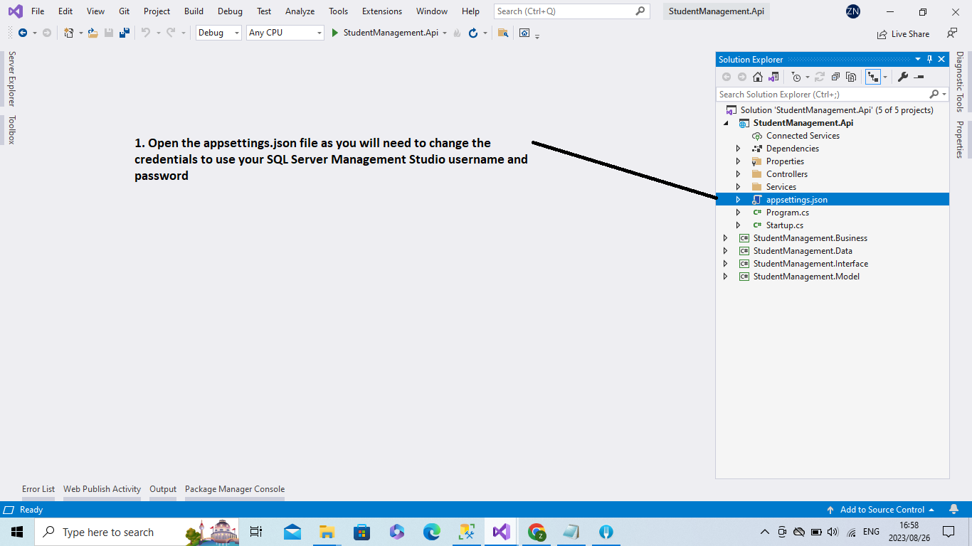

Change the following properties in the connection strings node to use your SQL Server Management Studio’s credentials:

* Data source
* User id
* Password

